My name is Mia Sklavounos and I work for Media Academy Cymru. I am a member of the Cerridwen team in Cardiff and we would love to take on more referrals so we can support young people. On behalf of my team, thank you for taking some time to learn about our service. Please share this information with other colleagues, organisations or anyone else you feel may be of interest.

**Cerridwen** – Violence Reduction Programme

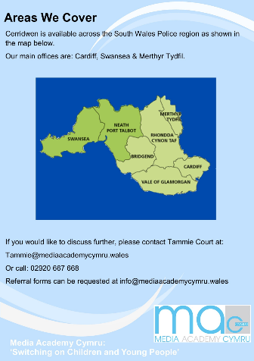

**Who is the programme for?**

Cerridwen is aimed at young people aged 10-17 who:

* Exhibit or are at risk of exhibiting violent behaviours and/or offending,
* Live in South Wales (the Cerridwen team in Merthyr reach out to the Cwmtaf area),
* Give their consent to engage with the programme and complete it voluntarily,
* Have been released from prison.

Violent behaviours include:

* Physical violence
* Pro-violent thoughts and opinions
* Verbal threats of physical violence
* Aggressive communication strategies

**Who can refer young people to the programme?**

Professionals in education, health and the third sector as well as parents and young people.

**How can I learn more about the programme?**

Please feel free to contact us for more information. We offer information session on our services either in person or on Microsoft Teams. We are happy to arrange informal meetings to meet the Cerridwen team which covers the Cwmtaf area – giving you the chance to find out more about us in our Merthyr office with a cup of coffee!

**Who can I contact to arrange an information session?**

Any member of the Cerridwen team from Cardiff, Swansea or Merthyr.

**How can I make a referral?**

Complete a MAC referral form for the Cadiff/Swansea/Merthyr area (form attached, please download) and send the form by email to [referrals@mediaacademycymru.wales](mailto:referrals@mediaacademycymru.wales) .

**What if I’d like to discuss a potential referral before submitting?**

Email Tammie Court/Mia Sklavounos – [tammie@mediaacademycymru.wales](mailto:tammie@mediaacademycymru.wales) / [mia@mediaacademycymru.wales](mailto:mia@mediaacademycymru.wales) – or phone 02920 667668 to discuss your referral before you submit.

We look forward to hearing back from you!