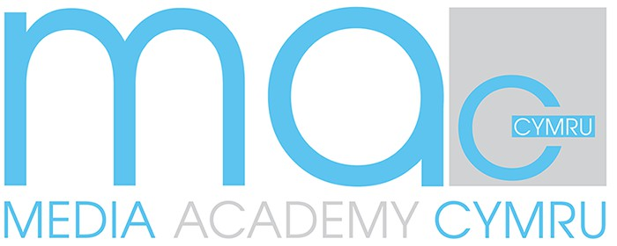OVERVIEW OF CARDIFF SERVICES

CERRIDWEN: An intervention aimed at reducing violence and increasing empathy. Cerridwen seeks to empower young people to make healthy and positive life choices through a youth work approach. The programme develops trusting relationships that builds emotional resilience, improves wellbeing, and challenges negative narratives, reducing the likelihood of future violent behaviours. This is a voluntary programme for young people aged between 10-17 either by self-referral or agency referral.

BRAVER CHOICES: The Braver Choices programme is a 12-week intervention, designed for young people aged 8-18 years old who are engaging with weapons. The programme is delivered on a 1:1 basis, in a safe environment that is tailored to the individual’s needs and abilities. Over the course of 12 weeks, each young person will explore and learn about the risks of carrying weapons, exploitation, consequential thinking and individual safety planning.

PARALLEL LIVES: This is a four-tiered support service (Base, Build, Boost, Beyond), which supports families who are experiencing adolescent to parent violence/abuse (APVA). Our services include a support line (Base), a virtual workshop via Teams for parents/carers (Build), a one-day workshop focusing on raising parental presence and non-violent resistance strategies for parents/carers (Boost) and a more intensive, 7-week intervention where we work with both the young person and the parent/carer in a group or 1:1 setting (Beyond). Our Beyond service is strength-based, restorative and uses psycho-educative approaches. Individuals learn to identify feelings that can lead them into negative cycles with people in their lives and learn how to reverse negative relationship patterns that may have developed. Workshops with young people and their parents/carers are initially run separately, but in parallel. The programme encourages the development of self-reflection into their own relationships and for individual voices to be heard. The programme concludes with parents/caregivers and young people working together to share their new understanding, knowledge, and strategies to form a mutually agreed plan for moving forward with reduced/no conflict.

POSITIVE MASCULINITY: The Positive Masculinity Initiative aims to work with young people who are exhibiting or in the presence of misogynistic rhetoric or behaviours. The project is designed to engage with and mentor children and young people (aged 10-17) both on a one-to-one basis and in group-based or classroom settings. The programme aims to raise awareness and understanding around misogyny and gender-based violence, to challenge and safeguard, whilst encouraging young people to move into more positive, socially acceptable thoughts, attitudes and behaviours. Through youth work values and methods, we support participants to adopt pro-social values and attitudes towards people, irrespective of gender, race and sexuality. The initiative also aims to enable both adults and young people to identify traits of negative behaviours in the young people around them and collectively reclaim the spaces that have been encroached into, by empowering young people to recognise their own susceptibility and speak up when they feel vulnerable.

EDUCATION at MAC: MAC offers non-formal, alternative education provision for 16–25-year-olds. We strive to remove all barriers to learning and prioritise well-being. As well as gaining recognised qualifications, a key focus is on developing social and employability skills through a sensitive and holistic support package, delivered in small groups. Courses at MAC are practical, creative, hands-on, engaging and taught in a relaxed, fully inclusive learning environment. Our primary aim is to help each young person realise their potential and to learn in a place where they can be their authentic self. No qualifications or previous experience are required to enroll. MAC education programmes are run in partnership with Cardiff and Vale College and Creative Wales.

PEER ACTION COLLECTIVE CYMRU: PAC Cymru is a research and social action collective of young people who meet to offer opportunities for other young people aged 10-25, to assemble as changemakers to stop violence in Wales. PAC offers freelance paid opportunities for young people as peer researchers and free activities for changemakers developing creative responses to negative stimuli in their world.

HOW TO REFER

To refer into any of the MAC services or for further in[formation please email:](mailto:info@mediaacademycymru.wales) [info@mediaacademycymru.wales,](mailto:info@mediaacademycymru.wales) or call our head office on 02920 667 668.